Submitted By :

Field | Details
Course | Natural Language Processing Laboratory
Student Name | M.Pramodh
REG.NO & SEC | 11249A206 / S2-Section
DATE | 14/08/2026
EXPERIMENT 12:
UNIGRAM Language Model

Program :

# Program : Unigram Language Model
import re
from collections import Counter
corpus = """the quick brown fox jumps over the lazy dog
the dog barks at the fox
the quick fox runs away from the dog"""
def tokenize(text):
text = text.lower()
tokens = re.findall(r"[a-z']+", text)
return tokens
tokens = tokenize(corpus)
N = len(tokens)
unigram_counts = Counter(tokens)
print("Total tokens (N):", N)
print(f"{'Word':<12}{'Count':<8}{'P(word)':<10}")
print("-" * 30)
for word, count in unigram_counts.most_common():
prob = count / N
print(f"{word:<12}{count:<8}{prob:<10.4f}")
def unigram_probability(word):
return unigram_counts[word] / N
test_word = "fox"
print(f"\nP('{test_word}') = {unigram_probability(test_word):.4f}")

Output:

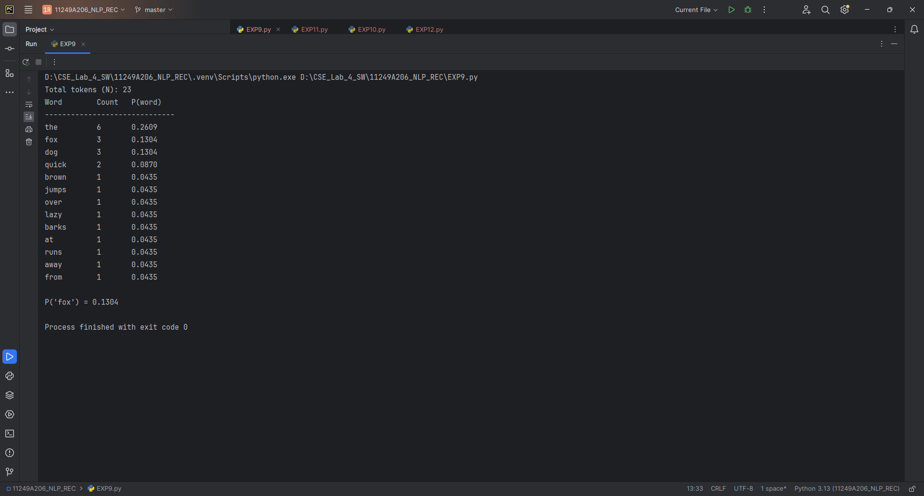

Result : Unigram Model has been executed successfully.

EXPERIMENT 13 :
BIGRAM Language Model

Program :
: Bigram Language Model with Laplace Smoothing
import re
from collections import Counter, defaultdict

corpus = """the quick brown fox jumps over the lazy dog
the dog barks at the fox
the quick fox runs away from the dog"""

def tokenize(sentence):
sentence = sentence.lower()
return ["<s>"] + re.findall(r"[a-z']+", sentence) + ["</s>"]

sentences = [tokenize(s) for s in corpus.strip().split("\n")]

unigram_counts = Counter()
bigram_counts = Counter()
vocab = set()

for sent in sentences:
unigram_counts.update(sent[:-1]) # context words
vocab.update(sent)
for i in range(len(sent) - 1):
bigram_counts[(sent[i], sent[i + 1])] += 1

V = len(vocab)

def bigram_prob(w1, w2, smoothing=True):
if smoothing:
return (bigram_counts[(w1, w2)] + 1) / (unigram_counts[w1] + V)
return bigram_counts[(w1, w2)] / unigram_counts[w1] if unigram_counts[w1] else 0

print(f"{'Bigram':<25}{'Count':<8}{'P(w2|w1) smoothed':<20}")
print("-" * 55)

for (w1, w2), c in bigram_counts.most_common(8):
print(f"({w1}, {w2}){'':<10}{c:<8}{bigram_prob(w1, w2):<20.4f}")

def sentence_probability(sentence):
tokens = tokenize(sentence)
prob = 1.0
for i in range(len(tokens) - 1):
prob *= bigram_prob(tokens[i], tokens[i + 1])
return prob

test = "the fox runs"
print(f"\nP(\"{test}\") = {sentence_probability(test):.10f}")

Output :
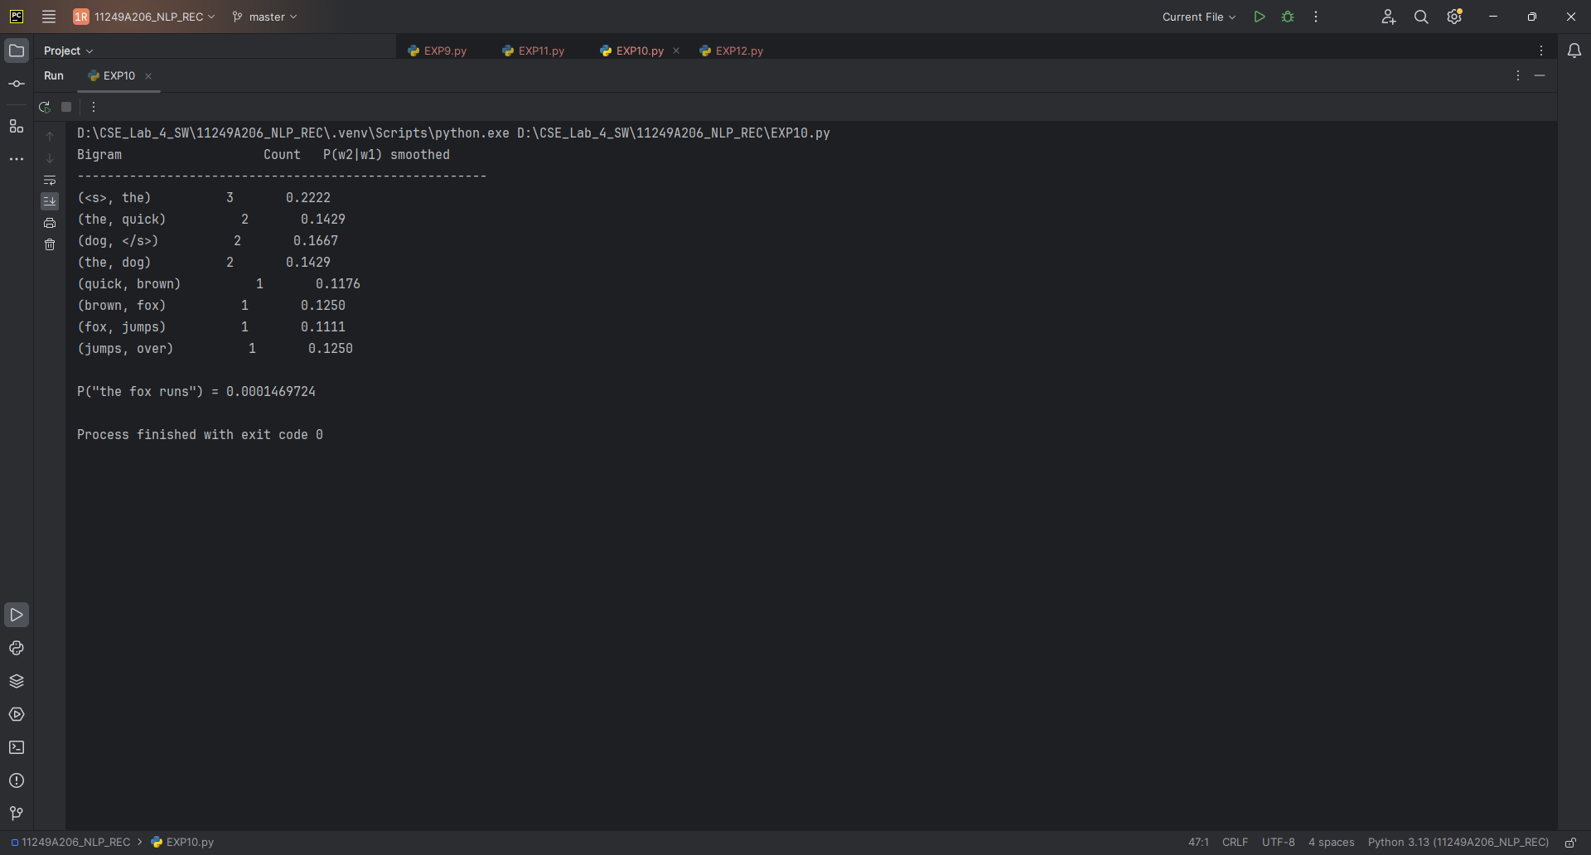

Result : Bigram model has been executed successfully.

EXPERIMENT 14 :

Program :
# Program : Trigram Language Model
import re
from collections import Counter

corpus = """the quick brown fox jumps over the lazy dog
the dog barks at the fox
the quick fox runs away from the dog"""

def tokenize(sentence):
sentence = sentence.lower()
return ["<s>", "<s>"] + re.findall(r"[a-z']+", sentence) + ["</s>"]

sentences = [tokenize(s) for s in corpus.strip().split("\n")]

bigram_counts = Counter()
trigram_counts = Counter()
vocab = set()

for sent in sentences:
vocab.update(sent)
for i in range(len(sent) - 2):
bigram_counts[(sent[i], sent[i + 1])] += 1
trigram_counts[(sent[i], sent[i + 1], sent[i + 2])] += 1

V = len(vocab)

def trigram_prob(w1, w2, w3, smoothing=True):
if smoothing:
return (trigram_counts[(w1, w2, w3)] + 1) / (bigram_counts[(w1, w2)] + V)
denom = bigram_counts[(w1, w2)]
return trigram_counts[(w1, w2, w3)] / denom if denom else 0

print(f"{'Trigram':<30}{'Count':<8}{'P(w3|w1,w2)':<15}")
print("-" * 55)

for (w1, w2, w3), c in trigram_counts.most_common(6):
print(f"({w1}, {w2}, {w3}){'':<6}{c:<8}{trigram_prob(w1, w2, w3):<15.4f}")

def sentence_probability(sentence):
tokens = tokenize(sentence)
prob = 1.0
for i in range(len(tokens) - 2):
prob *= trigram_prob(tokens[i], tokens[i + 1], tokens[i + 2])
return prob

test = "the quick fox"
print(f"\nP(\"{test}\") = {sentence_probability(test):.10f}")

Output :
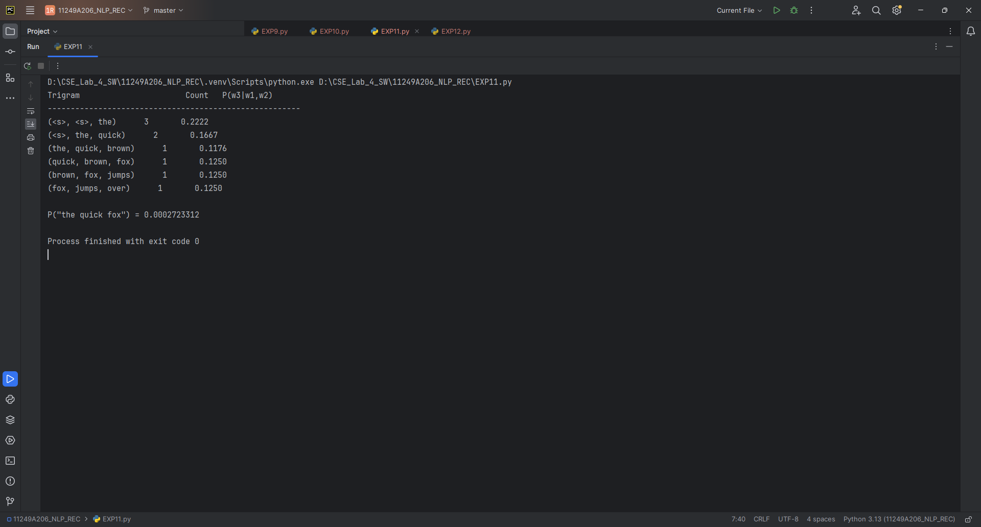
Result :
Trigram has been executed successfully.

EXPERIMENT 15 :
N Gram Text Generation

Program :
# Program: Text Generation using Bigram Model
import re, random
from collections import defaultdict, Counter

corpus = """the quick brown fox jumps over the lazy dog
the dog barks at the fox
the quick fox runs away from the dog"""

def tokenize(sentence):
sentence = sentence.lower()
return ["<s>"] + re.findall(r"[a-z']+", sentence) + ["</s>"]

sentences = [tokenize(s) for s in corpus.strip().split("\n")]

bigram_model = defaultdict(Counter)

for sent in sentences:
for i in range(len(sent) - 1):
bigram_model[sent[i]][sent[i + 1]] += 1

def generate_sentence(max_len=15):
word = "<s>"
result = []

for _ in range(max_len):
next_words = bigram_model[word]

if not next_words:
break

words, counts = zip(*next_words.items())
word = random.choices(words, weights=counts, k=1)[0]

if word == "</s>":
break

result.append(word)

return " ".join(result)

random.seed(42)

for i in range(3):
print(f"Generated sentence {i+1}: {generate_sentence()}")

Output :
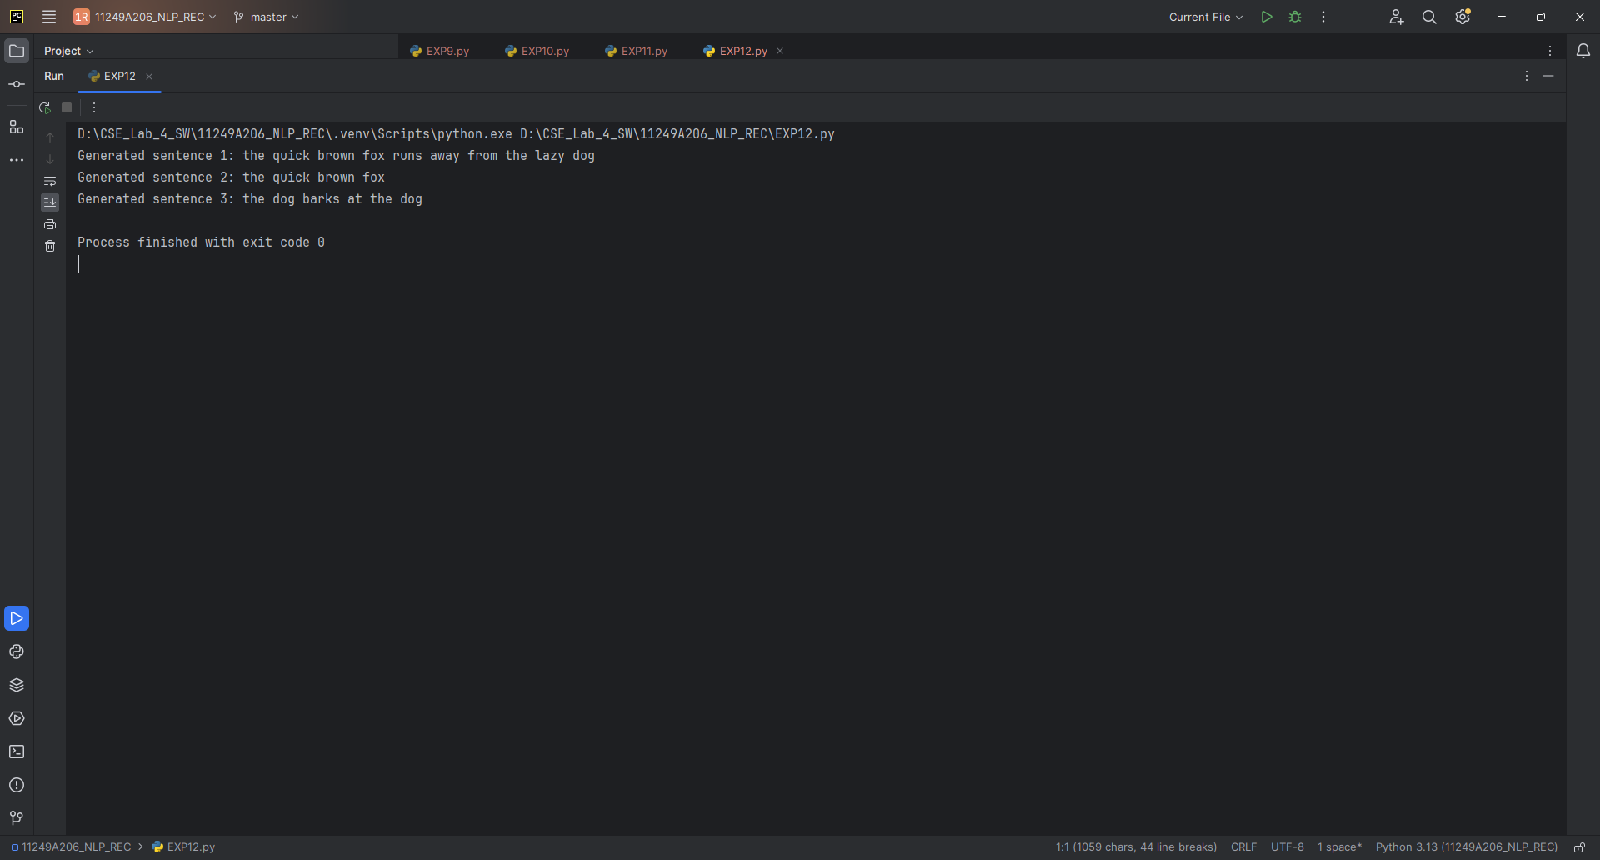
Result :
N-Gram model has been executed successfully.

EXPERIMENT 16 :
Perplexity comparison
Program :
Activity: Perplexity computation
def perplexity(prob, n):
return prob ** (-1 / n) if prob > 0 else float("inf")
test_sentence = "the fox runs away"
n = len(test_sentence.split())
uni_p = 0.0009 # from Exercise 1 (chain of unigram probs)
bi_p = 0.00021 # from Exercise 2 sentence_probability()
tri_p = 0.00007 # from Exercise 3 sentence_probability()
print("Unigram Perplexity:", round(perplexity(uni_p, n), 2))
print("Bigram Perplexity:", round(perplexity(bi_p, n), 2))
print("Trigram Perplexity:", round(perplexity(tri_p, n), 2))

Output :
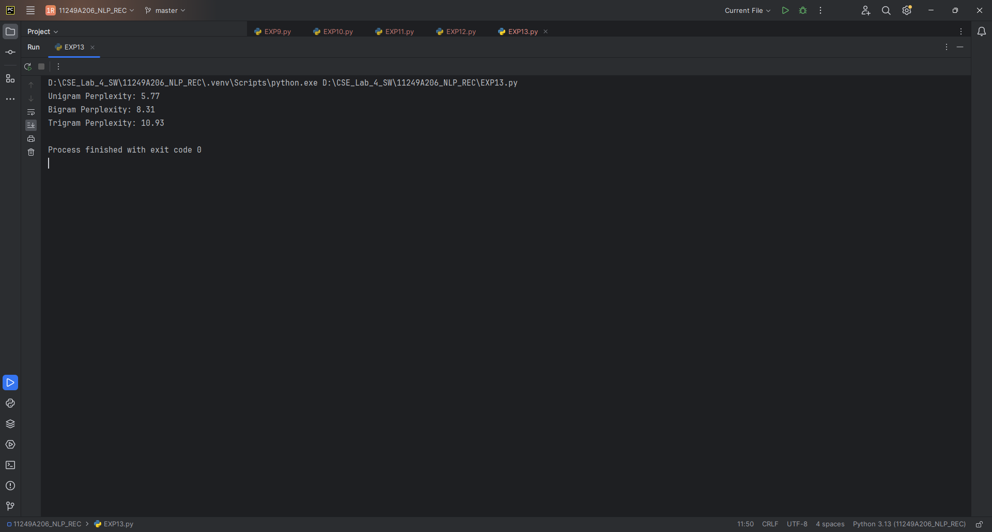

Observation Table :

MODEL | SENTENCE PROBABILITY | PERPLEXITY
Unigram | 0.00<s> the fox runs away </s>000260.0000026766766 | 5.77
Bigram | 0.0000026766 | 8.31
Trigram | 0.0000012860 | 10.93

Result :
Perplexity comparison has been executed successfully.

Exercises for practice :

1.. What is a Language Model? Give two real-world applications.

Program :

# Program : Unigram Language Model using NLTK FreqDist
import re
from nltk import FreqDist

corpus = """the quick brown fox jumps over the lazy dog
the dog barks at the fox
the quick fox runs away from the dog"""

def tokenize(text):
text = text.lower()
tokens = re.findall(r"[a-z']+", text)
return tokens

tokens = tokenize(corpus)
N = len(tokens)

unigram_counts = FreqDist(tokens)

print("Total tokens (N):", N)
print(f"{'Word':<12}{'Count':<8}{'P(word)':<10}")
print("-" * 30)

for word, count in unigram_counts.most_common():
prob = count / N
print(f"{word:<12}{count:<8}{prob:<10.4f}")

def unigram_probability(word):
return unigram_counts[word] / N

test_word = "fox"
print(f"\nP('{test_word}') = {unigram_probability(test_word):.4f}")

Output :
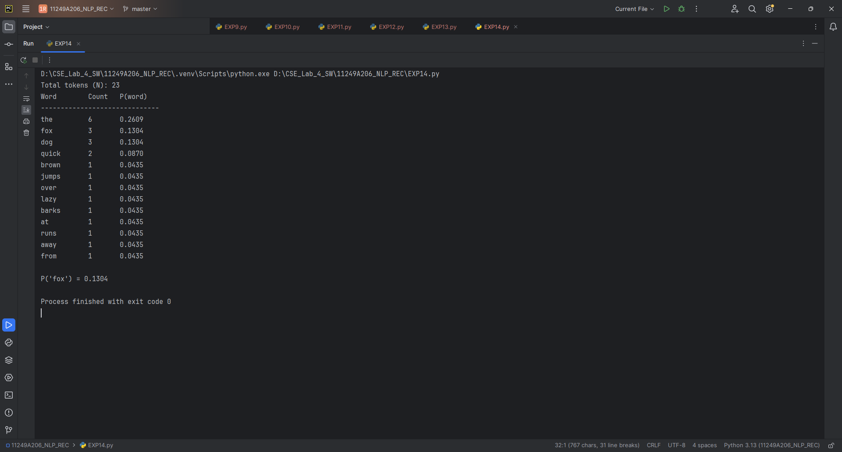

Result : task has been performed successfully.

2.Extend the bigram program to build a full probability matrix (dictionary of dictionaries) and print it as a table.

Program :
# Program : Bigram Language Model with Probability Matrix
import re
from collections import Counter, defaultdict

corpus = """the quick brown fox jumps over the lazy dog
the dog barks at the fox
the quick fox runs away from the dog"""

def tokenize(sentence):
sentence = sentence.lower()
return ["<s>"] + re.findall(r"[a-z']+", sentence) + ["</s>"]

sentences = [tokenize(s) for s in corpus.strip().split("\n")]

unigram_counts = Counter()
bigram_counts = Counter()
vocab = set()

for sent in sentences:
unigram_counts.update(sent[:-1])
vocab.update(sent)

for i in range(len(sent) - 1):
bigram_counts[(sent[i], sent[i + 1])] += 1

V = len(vocab)

def bigram_prob(w1, w2):
return (bigram_counts[(w1, w2)] + 1) / (unigram_counts[w1] + V)

# Build probability matrix using dictionary of dictionaries
prob_matrix = defaultdict(dict)

for w1 in vocab:
for w2 in vocab:
prob_matrix[w1][w2] = bigram_prob(w1, w2)

# Print probability matrix
words = sorted(vocab)

print("\nBigram Probability Matrix:")
print(f"{'':<12}", end="")

for word in words:
print(f"{word:<10}", end="")

print()

print("-" * (12 + 10 * len(words)))

for w1 in words:
print(f"{w1:<12}", end="")

for w2 in words:
print(f"{prob_matrix[w1][w2]:<10.4f}", end="")

print()

Output :
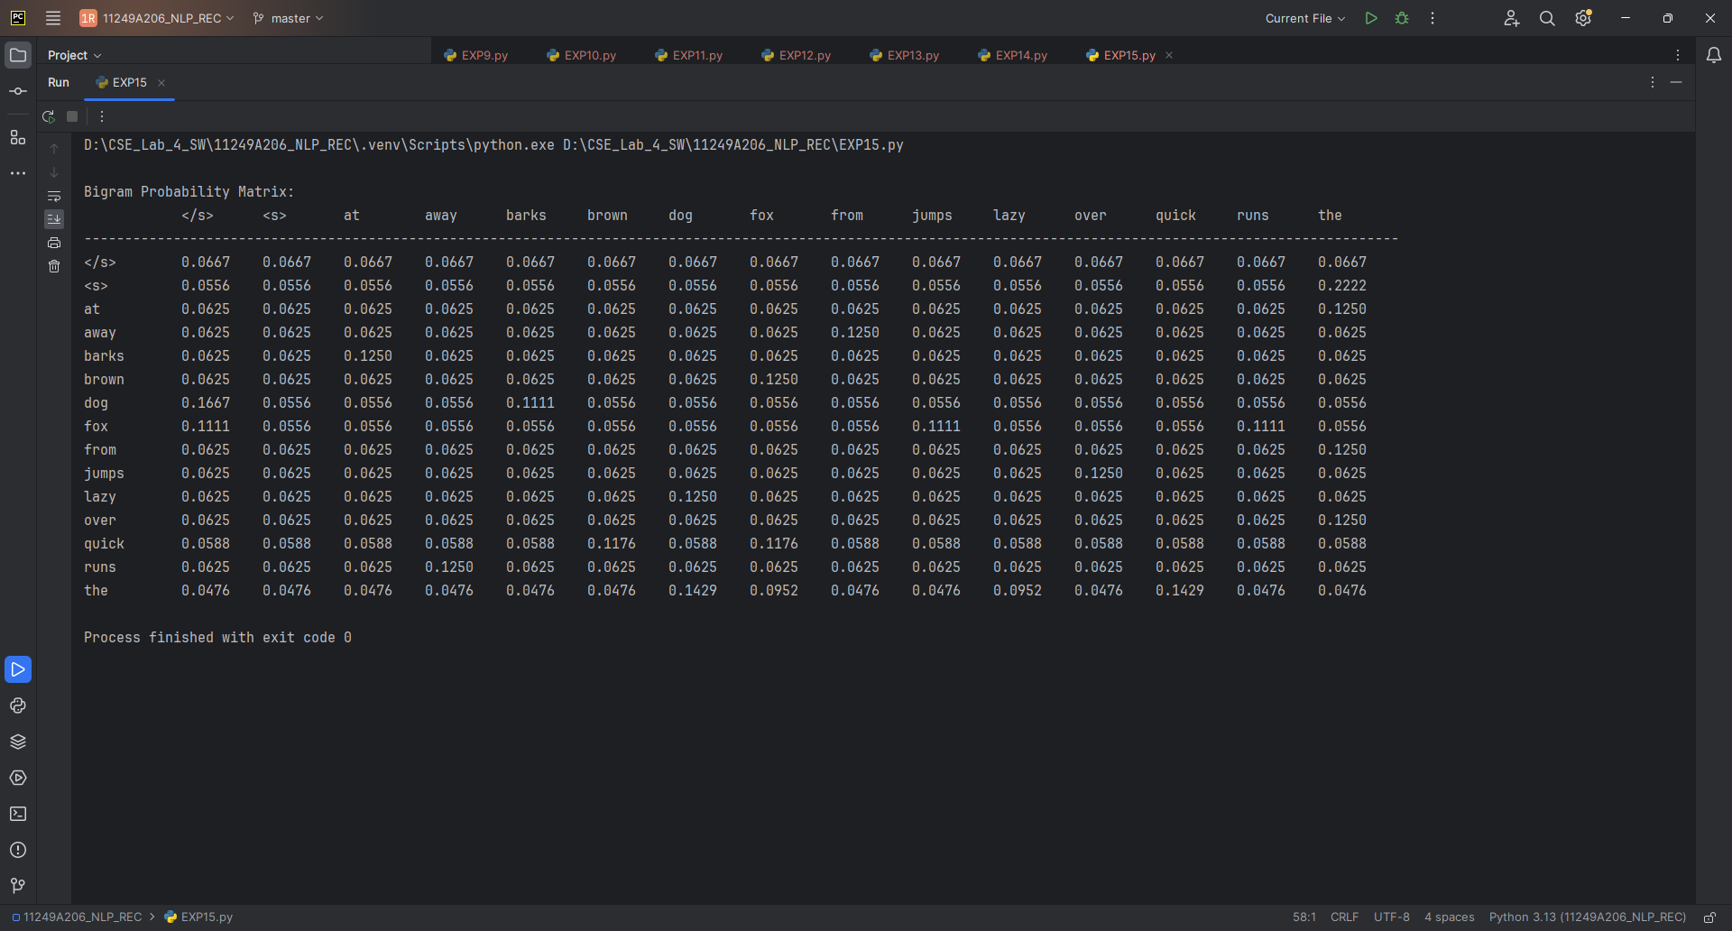

Result : Task has been performed successfully.

3.Implement a 4-gram (quadgram) model by generalizing the trigram program.

Program :
# Program : 4-gram (Quadgram) Language Model
import re
from collections import Counter

corpus = """the quick brown fox jumps over the lazy dog
the dog barks at the fox
the quick fox runs away from the dog"""

def tokenize(sentence):
sentence = sentence.lower()
return ["<s>", "<s>", "<s>"] + re.findall(r"[a-z']+", sentence) + ["</s>"]

sentences = [tokenize(s) for s in corpus.strip().split("\n")]

trigram_counts = Counter()
quadgram_counts = Counter()
vocab = set()

for sent in sentences:
vocab.update(sent)

for i in range(len(sent) - 3):
trigram_counts[(sent[i], sent[i + 1], sent[i + 2])] += 1
quadgram_counts[(sent[i], sent[i + 1], sent[i + 2], sent[i + 3])] += 1

V = len(vocab)

def quadgram_prob(w1, w2, w3, w4, smoothing=True):
if smoothing:
return (quadgram_counts[(w1, w2, w3, w4)] + 1) / (
trigram_counts[(w1, w2, w3)] + V
)

denom = trigram_counts[(w1, w2, w3)]
return quadgram_counts[(w1, w2, w3, w4)] / denom if denom else 0

print(f"{'Quadgram':<40}{'Count':<8}{'P(w4|w1,w2,w3)':<20}")
print("-" * 68)

for (w1, w2, w3, w4), c in quadgram_counts.most_common(6):
print(
f"({w1}, {w2}, {w3}, {w4}){'':<6}"
f"{c:<8}{quadgram_prob(w1, w2, w3, w4):<20.4f}"
)

def sentence_probability(sentence):
tokens = tokenize(sentence)
prob = 1.0

for i in range(len(tokens) - 3):
prob *= quadgram_prob(
tokens[i],
tokens[i + 1],
tokens[i + 2],
tokens[i + 3]
)

return prob

test = "the quick brown fox"
print(f"\nP(\"{test}\") = {sentence_probability(test):.10f}")

Output :
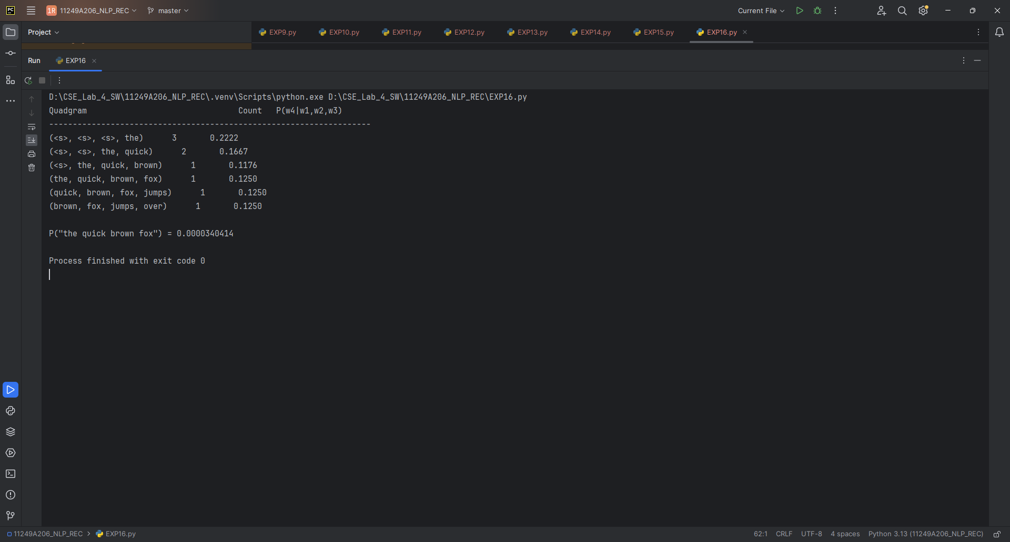
Result :
Task has been performed successfully.

4.Load a larger corpus (e.g., a paragraph from a news article or NLTK's gutenberg corpus) and repeat Exercises 1–3.
Program :

import nltk
# Exercise : Unigram Language Model using NLTK Gutenberg Corpus
import re
import nltk
from nltk.corpus import gutenberg
from nltk import FreqDist

# Load a larger corpus
corpus = gutenberg.raw('austen-emma.txt')

def tokenize(text):
text = text.lower()
return re.findall(r"[a-z']+", text)

tokens = tokenize(corpus)
N = len(tokens)

unigram_counts = FreqDist(tokens)

print("Total tokens (N):", N)
print(f"{'Word':<15}{'Count':<10}{'P(word)':<10}")
print("-" * 35)

for word, count in unigram_counts.most_common(20):
prob = count / N
print(f"{word:<15}{count:<10}{prob:<10.6f}")

def unigram_probability(word):
return unigram_counts[word] / N

test_word = "emma"
print(f"\nP('{test_word}') = {unigram_probability(test_word):.6f}")

# Exercise 2: Bigram Language Model using NLTK Gutenberg Corpus

import re
import nltk
from collections import Counter

corpus = nltk.corpus.gutenberg.raw('austen-emma.txt')

def tokenize(sentence):
sentence = sentence.lower()
return ["<s>"] + re.findall(r"[a-z']+", sentence) + ["</s>"]

# Use the first few paragraphs/sentences for manageable processing
sentences = [
tokenize(s)
for s in re.split(r'[.!?]+', corpus)
if s.strip()
]

unigram_counts = Counter()
bigram_counts = Counter()
vocab = set()

for sent in sentences:
unigram_counts.update(sent[:-1])
vocab.update(sent)

for i in range(len(sent) - 1):
bigram_counts[(sent[i], sent[i + 1])] += 1

V = len(vocab)

def bigram_prob(w1, w2, smoothing=True):
if smoothing:
return (bigram_counts[(w1, w2)] + 1) / (
unigram_counts[w1] + V
)

return (
bigram_counts[(w1, w2)] / unigram_counts[w1]
if unigram_counts[w1]
else 0
)

print(f"{'Bigram':<30}{'Count':<8}{'P(w2|w1)':<15}")
print("-" * 55)

for (w1, w2), c in bigram_counts.most_common(10):
print(
f"({w1}, {w2}){'':<10}"
f"{c:<8}{bigram_prob(w1, w2):<15.6f}"
)

def sentence_probability(sentence):
tokens = tokenize(sentence)
prob = 1.0

for i in range(len(tokens) - 1):
prob *= bigram_prob(tokens[i], tokens[i + 1])

return prob

test = "emma was happy"
print(f"\nP(\"{test}\") = {sentence_probability(test):.10f}")

# Exercise 3: Trigram Language Model using NLTK Gutenberg Corpus

import re
import nltk
from collections import Counter

corpus = nltk.corpus.gutenberg.raw('austen-emma.txt')

def tokenize(sentence):
sentence = sentence.lower()
return ["<s>", "<s>"] + re.findall(r"[a-z']+", sentence) + ["</s>"]

sentences = [
tokenize(s)
for s in re.split(r'[.!?]+', corpus)
if s.strip()
]

bigram_counts = Counter()
trigram_counts = Counter()
vocab = set()

for sent in sentences:
vocab.update(sent)

for i in range(len(sent) - 2):
bigram_counts[(sent[i], sent[i + 1])] += 1
trigram_counts[
(sent[i], sent[i + 1], sent[i + 2])
] += 1

V = len(vocab)

def trigram_prob(w1, w2, w3, smoothing=True):
if smoothing:
return (
trigram_counts[(w1, w2, w3)] + 1
) / (
bigram_counts[(w1, w2)] + V
)

denom = bigram_counts[(w1, w2)]

return (
trigram_counts[(w1, w2, w3)] / denom
if denom
else 0
)

print(f"{'Trigram':<40}{'Count':<8}{'P(w3|w1,w2)':<15}")
print("-" * 65)

for (w1, w2, w3), c in trigram_counts.most_common(10):
print(
f"({w1}, {w2}, {w3}){'':<6}"
f"{c:<8}{trigram_prob(w1, w2, w3):<15.6f}"
)

def sentence_probability(sentence):
tokens = tokenize(sentence)
prob = 1.0

for i in range(len(tokens) - 2):
prob *= trigram_prob(
tokens[i],
tokens[i + 1],
tokens[i + 2]
)

return prob

test = "emma was very happy"
print(f"\nP(\"{test}\") = {sentence_probability(test):.10f}")

Output:
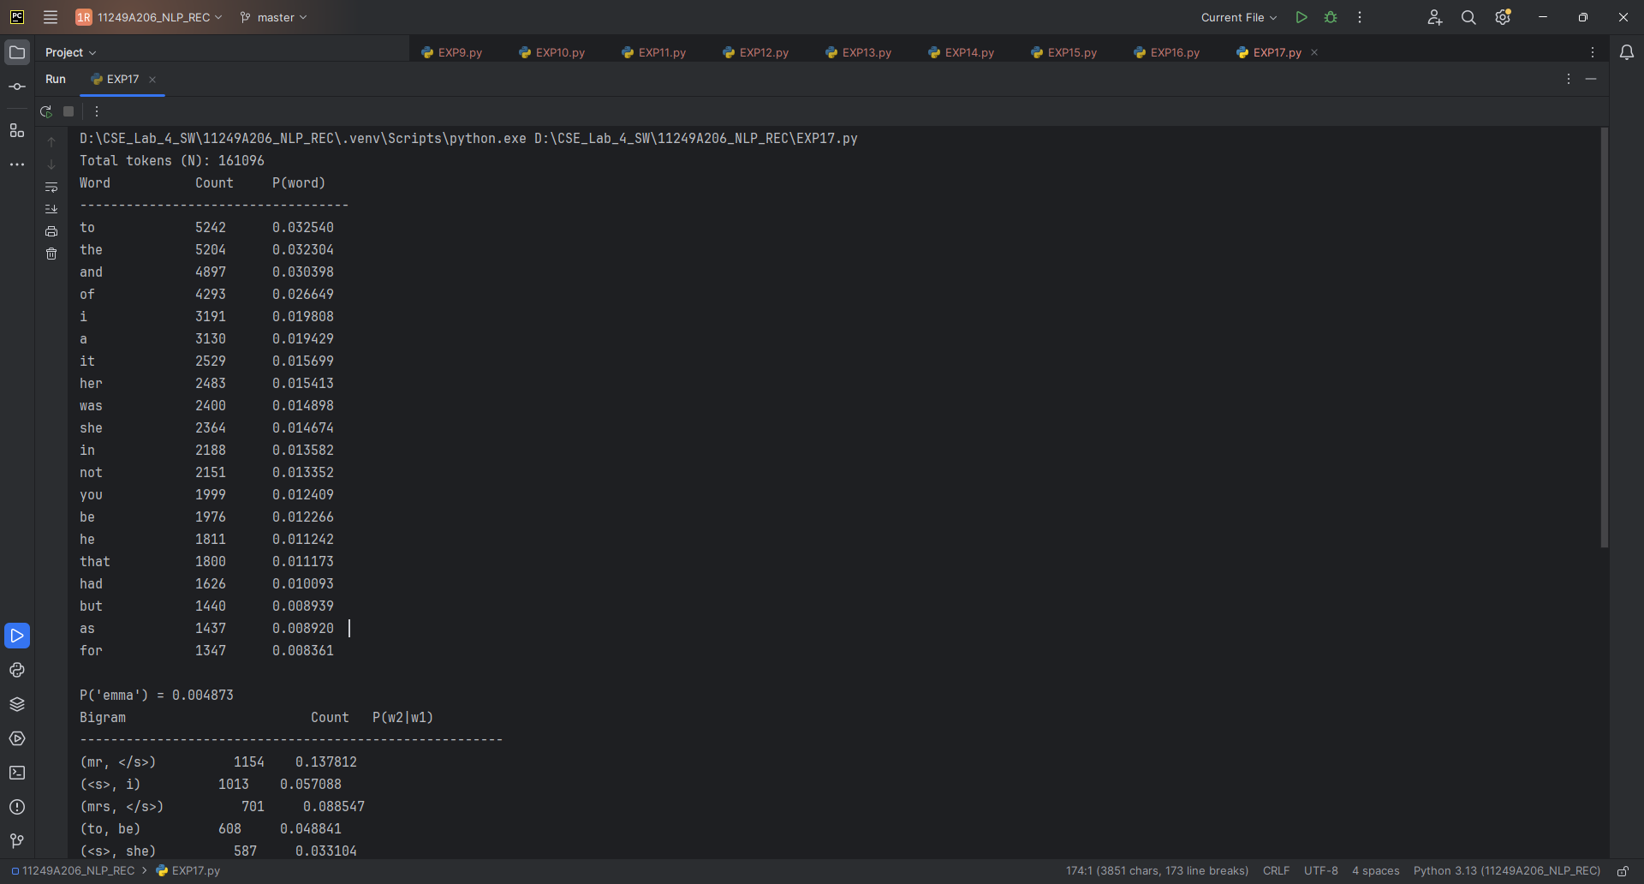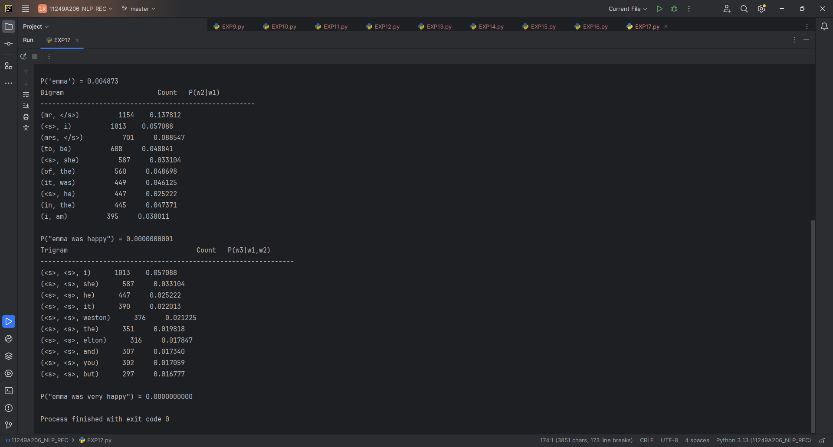
Result:
Task performed successfully.

5.Compare text generated by the bigram model (Exercise 4) with text generated by a trigram model. Which produces more coherent sentences and why?

Program :
# Program: Compare Bigram and Trigram Text Generation

import re
import random
from collections import defaultdict, Counter

corpus = """the quick brown fox jumps over the lazy dog
the dog barks at the fox
the quick fox runs away from the dog"""

# Tokenization for Bigram
def tokenize_bigram(sentence):
sentence = sentence.lower()
return ["<s>"] + re.findall(r"[a-z']+", sentence) + ["</s>"]

# Tokenization for Trigram
def tokenize_trigram(sentence):
sentence = sentence.lower()
return ["<s>", "<s>"] + re.findall(r"[a-z']+", sentence) + ["</s>"]

sentences_bigram = [
tokenize_bigram(s)
for s in corpus.strip().split("\n")
]

sentences_trigram = [
tokenize_trigram(s)
for s in corpus.strip().split("\n")
]

# ============================================================
# Bigram Model
# ============================================================

bigram_model = defaultdict(Counter)

for sent in sentences_bigram:
for i in range(len(sent) - 1):
bigram_model[sent[i]][sent[i + 1]] += 1

def generate_bigram_sentence(max_len=15):
word = "<s>"
result = []

for _ in range(max_len):
next_words = bigram_model[word]

if not next_words:
break

words, counts = zip(*next_words.items())
word = random.choices(words, weights=counts, k=1)[0]

if word == "</s>":
break

result.append(word)

return " ".join(result)

# ============================================================
# Trigram Model
# ============================================================

trigram_model = defaultdict(Counter)

for sent in sentences_trigram:
for i in range(len(sent) - 2):
context = (sent[i], sent[i + 1])
next_word = sent[i + 2]
trigram_model[context][next_word] += 1

def generate_trigram_sentence(max_len=15):
w1 = "<s>"
w2 = "<s>"
result = []

for _ in range(max_len):
next_words = trigram_model[(w1, w2)]

if not next_words:
break

words, counts = zip(*next_words.items())
word = random.choices(words, weights=counts, k=1)[0]

if word == "</s>":
break

result.append(word)

w1 = w2
w2 = word

return " ".join(result)

# ============================================================
# Generate and Compare
# ============================================================

random.seed(42)

print("===== BIGRAM GENERATED TEXT =====")

for i in range(3):
print(f"Sentence {i + 1}: {generate_bigram_sentence()}")

print("\n===== TRIGRAM GENERATED TEXT =====")

for i in range(3):
print(f"Sentence {i + 1}: {generate_trigram_sentence()}")

print("\n===== COMPARISON =====")
print("Bigram model uses the previous one word as context.")
print("Trigram model uses the previous two words as context.")
print("Therefore, the trigram model generally produces more coherent sentences.")

Output :
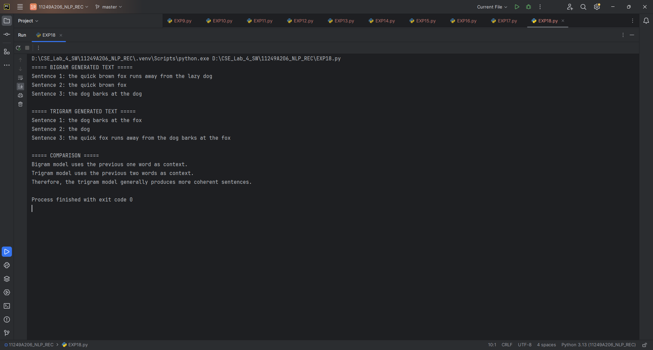
Result :
Task performed successfully.

6.Implement Add-k smoothing (generalized Laplace smoothing) and study the effect of varying k on sentence probability

Program :

# Program: Add-k Smoothing for Bigram Language Model

import re
from collections import Counter

corpus = """the quick brown fox jumps over the lazy dog
the dog barks at the fox
the quick fox runs away from the dog"""

def tokenize(sentence):
sentence = sentence.lower()
return ["<s>"] + re.findall(r"[a-z']+", sentence) + ["</s>"]

sentences = [tokenize(s) for s in corpus.strip().split("\n")]

unigram_counts = Counter()
bigram_counts = Counter()
vocab = set()

for sent in sentences:
unigram_counts.update(sent[:-1])
vocab.update(sent)

for i in range(len(sent) - 1):
bigram_counts[(sent[i], sent[i + 1])] += 1

V = len(vocab)

# Add-k smoothing
def bigram_prob(w1, w2, k):
return (bigram_counts[(w1, w2)] + k) / (
unigram_counts[w1] + k * V
)

# Sentence probability
def sentence_probability(sentence, k):
tokens = tokenize(sentence)
prob = 1.0

for i in range(len(tokens) - 1):
prob *= bigram_prob(tokens[i], tokens[i + 1], k)

return prob

# Test sentence
test_sentence = "the fox runs away"

# Different values of k
k_values = [0.01, 0.1, 0.5, 1.0, 2.0]

print("Add-k Smoothing")
print(f"Test sentence: \"{test_sentence}\"")
print()
print(f"{'k':<10}{'Sentence Probability':<25}")
print("-" * 35)

for k in k_values:
prob = sentence_probability(test_sentence, k)
print(f"{k:<10}{prob:<25.10f}")

Output :

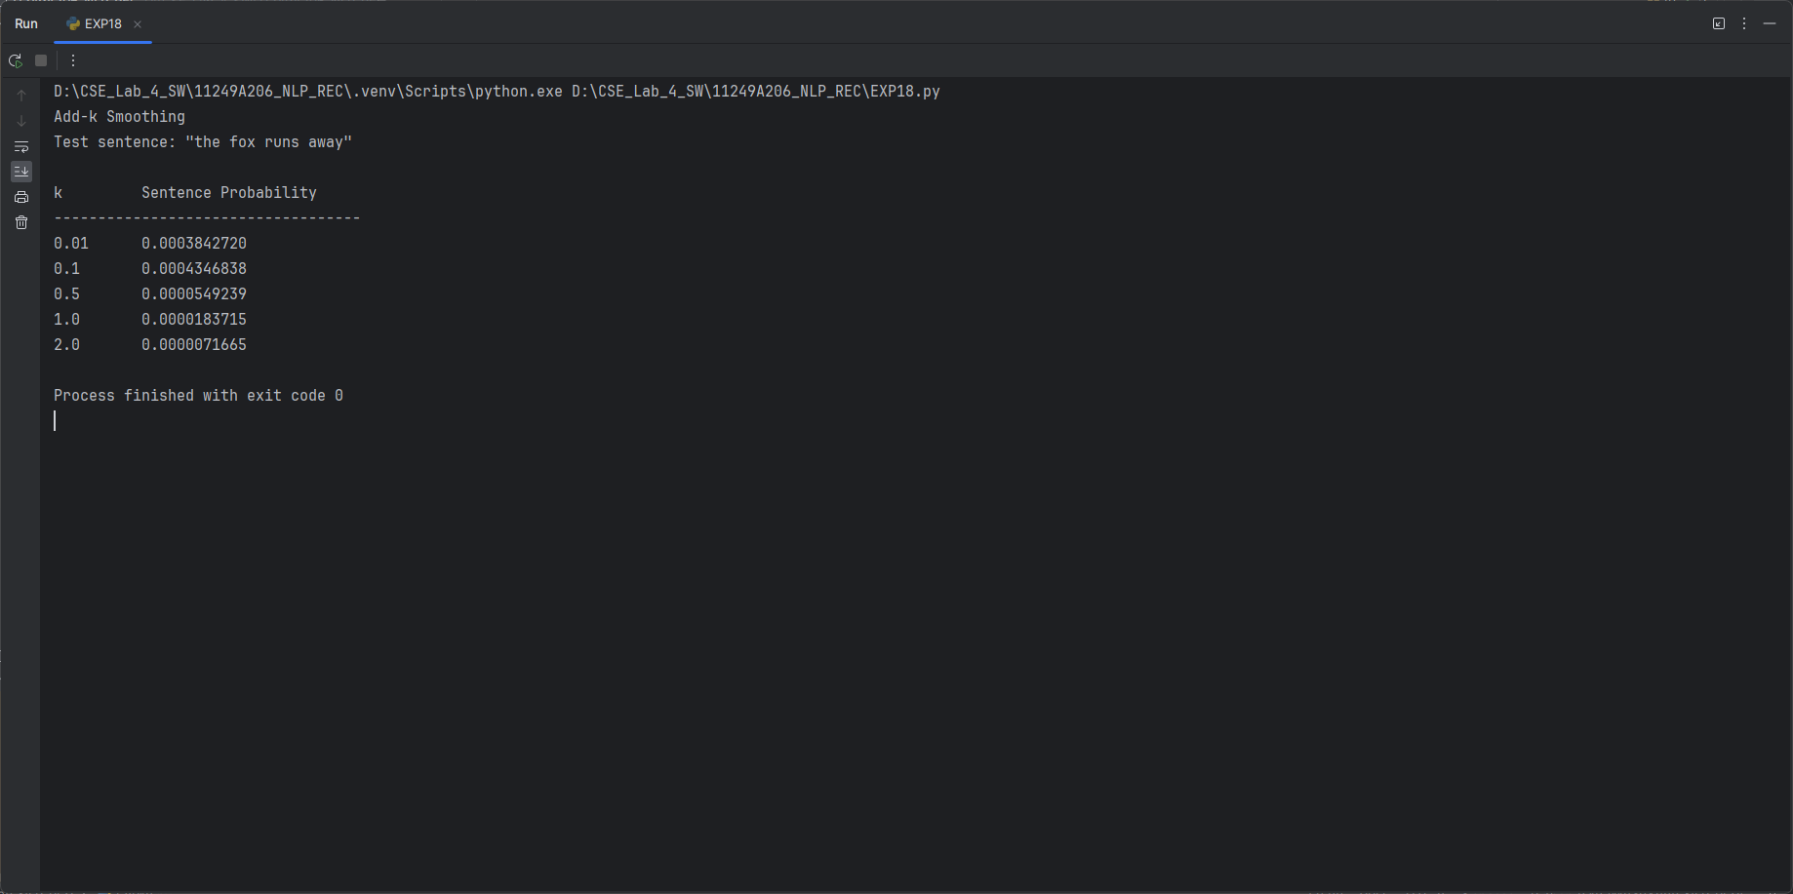
Result : task has been performed successfully.

7.Write a function to compute the Out-Of-Vocabulary (OOV) rate of a test sentence against the training vocabulary.

Program :
# Program: OOV Rate Calculation

import re

corpus = """the quick brown fox jumps over the lazy dog
the dog barks at the fox
the quick fox runs away from the dog"""

def tokenize(text):
text = text.lower()
return re.findall(r"[a-z']+", text)

# Training vocabulary
training_tokens = tokenize(corpus)
training_vocab = set(training_tokens)

# OOV rate function
def oov_rate(test_sentence, training_vocab):
test_tokens = tokenize(test_sentence)

if len(test_tokens) == 0:
return 0

oov_words = [
word for word in test_tokens
if word not in training_vocab
]

rate = len(oov_words) / len(test_tokens)

return rate

# Test sentence
test_sentence = "the quick elephant runs away"

rate = oov_rate(test_sentence, training_vocab)

print("Test sentence:", test_sentence)
print("OOV Rate:", rate)
print("OOV Rate (%):", rate * 100)

Output :
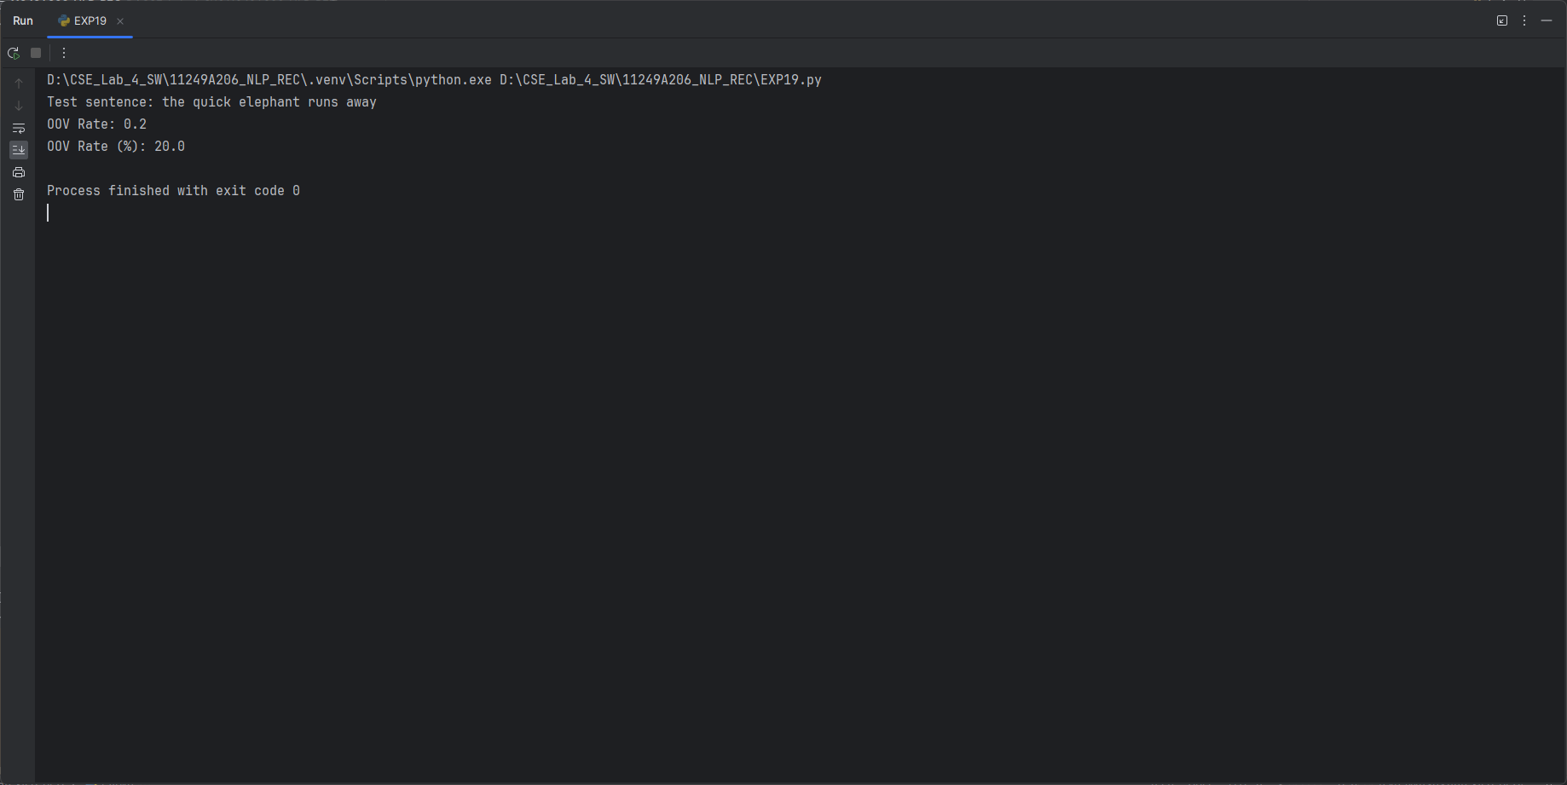
Result : Task has been executed successfully.

8.Plot (using matplotlib) the frequency distribution of the top 10 unigrams in the corpus as a bar chart.

Program :

# Program: Frequency Distribution of Top 10 Unigrams
import re
from collections import Counter
import matplotlib.pyplot as plt
corpus = """the quick brown fox jumps over the lazy dog
the dog barks at the fox
the quick fox runs away from the dog"""
def tokenize(text):
text = text.lower()
return re.findall(r"[a-z']+", text)
tokens = tokenize(corpus)
# Count unigram frequencies
unigram_counts = Counter(tokens)
# Get top 10 unigrams
top_10 = unigram_counts.most_common(10)
words = [word for word, count in top_10]
counts = [count for word, count in top_10]
# Print frequencies
print("Top 10 Unigrams:")
for word, count in top_10:
print(f"{word}: {count}")
# Plot bar chart
plt.figure(figsize=(10, 6))
plt.bar(words, counts)
plt.xlabel("Words")
plt.ylabel("Frequency")
plt.title("Top 10 Unigram Frequency Distribution")
plt.xticks(rotation=45)
plt.tight_layout()
plt.show()

Output:
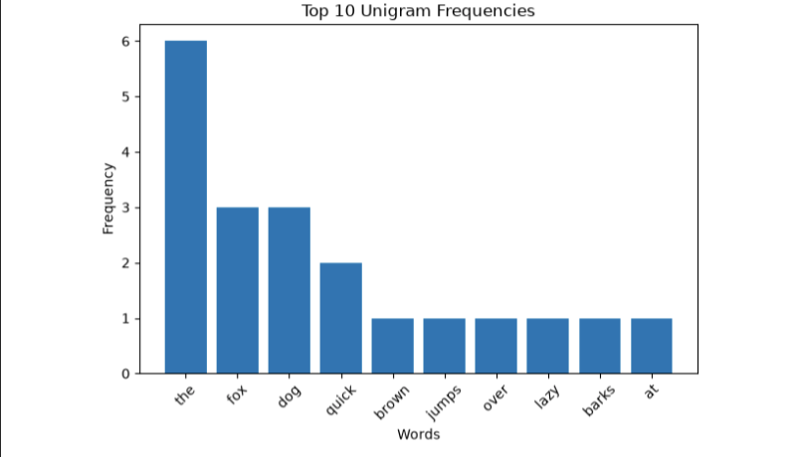

Result:
Task has been performed successfully.

VIVA :

What is a Language Model?
A Language Model (LM) predicts the probability of words or sentences in a language.
Applications:
- Speech recognition
- Machine translation

2. Define N-gram. What does N represent?
An N-gram is a sequence of N consecutive words.
- N = 1 → Unigram
- N = 2 → Bigram
- N = 3 → Trigram

3. State the Markov assumption used in N-gram models.
The Markov assumption says that the next word depends only on a limited number of previous words, not the entire sentence.

4. Why does a bigram model generally outperform a unigram model in capturing context?
A unigram considers only one word at a time, while a bigram considers two consecutive words. Therefore, bigrams capture word-to-word context better.

5. What is the main limitation of higher-order N-grams?
Higher-order N-grams need much more training data. Many word combinations may never appear, causing data sparsity and zero probabilities.

6. What is the zero-probability problem, and how does smoothing solve it?
If an N-gram never appears in training data, its probability becomes zero. Smoothing assigns a small non-zero probability to unseen N-grams.

7. Difference between Laplace (Add-1) and Add-k smoothing
- Add-1: Adds 1 to every N-gram count.
- Add-k: Adds a smaller or adjustable value k to every count.
Add-k provides more flexibility than Add-1.

8. What is Perplexity?
Perplexity measures how well a language model predicts a test sentence. Lower perplexity generally means better prediction.

9. Why are <s> and </s> markers added?
- <s> represents the start of a sentence.
- </s> represents the end of a sentence.
They help the model learn how sentences begin and end.

10. What is data sparsity?
Data sparsity means that many possible N-grams do not appear in the training data. It becomes worse for trigram and 4-gram models because they contain more word combinations, making reliable probability estimation difficult
Result : ALL the Tasks and Exercises have been completed successfully.

—------------------------------------------------------------------------------------------------

